TERMS OF REFERENCE AND SCOPE OF ACTIVITIES
MENTOR 1
FOR
SERBIA SCALING UP RESIDENTIAL CLEAN ENERGY (SURCE) PROJECT

Background
The Government of the Republic of Serbia (GoS) has secured financing from the International Bank for Reconstruction and Development (IBRD), which is part of the World Bank Group, to implement the Serbia ‘Scaling Up Residential Clean Energy’ (SURCE) Project, hereinafter the “Project”. The development objective of the Project is to increase the uptake of energy efficiency (EE), sustainable heating, and rooftop solar photovoltaics (RSPV) by households in participating local self-government units (LSGUs) in Serbia. An important associated objective is to reduce greenhouse gas (GHG) emissions and improve air quality thanks to achieved energy savings and reduced use of solid fuels for heating. These objectives will be achieved by two project components:
Component 1: Financing Energy Efficiency, Sustainable Heating, and Rooftop Solar Investments in Residential Buildings, with a key focus on single-family houses (SFHs).
Component 2: Technical Assistance and Implementation Support, with the overall aim of supporting the development of scalable financing mechanisms and removing market barriers, with three subcomponents: (a) enhancing local market capacity, improving enabling environment, and strengthening public awareness; (b) technical studies informing program design and implementation; and (c) project implementation support.

Components 1 and 2 will be implemented simultaneously; together they represent USD 50 million with Component 1 being allocated the major share of loan proceeds. Investments will be financed under Component 1 and scaled up relying on the analytical insights, institutional structures, and financing mechanisms developed under Component 2. The Ministry of Mining and Energy (MoME) might provide additional funds from the government budget to expand the scope of the investments.

The project will scale up a revised version of an existing government program, piloted in 2021, financing residential EE investments through a combination of public grants and leveraged private-sector financing. The investments under Component 1 will be financed through: (a) partial grants financed through the Project, offered by the MoME and channeled through participating local self-governing units (LSGUs); (b) partial grants offered by the LSGUs directly, in parallel with the IBRD financing channeled through the Project; and (c) household contributions, financed either from savings or borrowings (Figure 1).

Figure 1. Structure of the Project, with the LSGU playing a pivotal role and the citizen required to pay a share of the investment

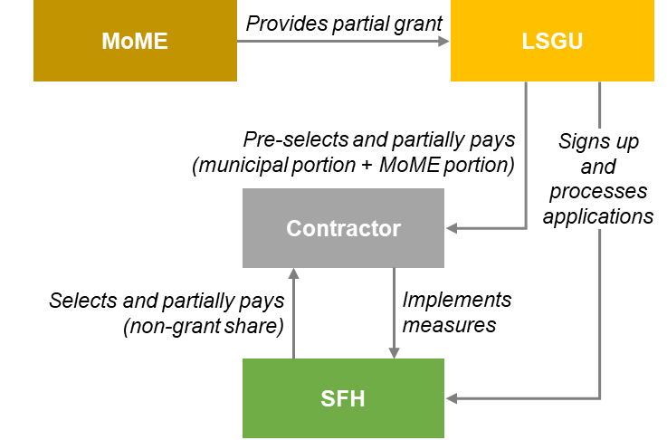

Notes: MoME: Ministry of Mining and Energy; SFH: single-family house; LSGU: Local self-government unit.
Source: World Bank staff.

The Project became effective in December 2022 and will be implemented over a 5-year period until November 2027. The overall responsibility for implementation of the Project rests with the Government of Serbia, with the MoME acting as implementing entity. The MoME will establish a Project Implementation Unit (PIU) to carry out the day-to-day activities of Project implementation. The PIU will coordinate closely with the MoME as well as the World Bank energy team responsible for the Project implementation on IBRD side. SURCE implementation will be also facilitated by the Administration for Energy Efficiency Financing and Promotion (hereinafter Energy Efficiency Administration, EEA) which has a coordinating role for clean energy and energy efficiency programs across government.
The Ministry of Finance (MoF) will provide SURCE Loan Agreement oversight and serve as the financial guarantor for all IFI-funded projects. The Central Fiduciary Unit (CFU), housed within the Ministry of Finance, will assist the SURCE PIU in the implementation of the financial management arrangements of the Project including planning and budgeting, accounting, financial reporting, flow of funds (including disbursement), internal controls, and external auditing, ensuring that these activities are carried out in line with the World Bank procedures.
The MoME intends to engage a consultant to take on the assignment of a Mentor 1 in the PIU (hereunder the Consultant). A part of the proceeds of the IBRD loan will be used for financing the proposed consultancy assignment. These Terms of Reference define the scope of activities and responsibilities of the Consultant. Additional PIU staff will be recruited under separate TORs for key positions and will include, among others, the Head of the PIU, an engineer, an environmental and social safeguard expert, and an IT expert.

Objective of the assignment
The objective of this assignment is to accelerate Project development and implementation by strengthening the capacity of LSGUs in various aspects.

Scope of Work
The Consultant will be responsible for:
- Project implementation and progress through the following activities: Provide one-on-one or group mentorship sessions for LSGU representatives, offer guidance on governance, administration, financial management, and service delivery, assist LSGUs in setting and achieving project-related goals, facilitate the exchange of best practices and successful case studies, support LSGUs in overcoming challenges related to project implementation, monitor the progress of LSGUs and provide constructive feedback, collaborate with project team members to align mentorship activities with overall project objectives, document mentorship sessions and provide progress reports.
The project is a collaborative initiative involving local self-government units (LSGUs). The consultant will be responsible for strengthening the capacity of LSGUs in various aspects, to This is a hands-on support for LSGUs throughout the project implementation.
- Performing activities related to implementation and execution of the Project through monitoring and reporting system, which includes the establishment of practice and materials that will be able to assist LSGUs in successfully navigating and implementing project activitiesThe consultant aims to foster knowledge sharing, best practices, and problem-solving strategies to ensure project success.
- The consultant will be responsible for guiding and monitoring LSGUs by carrying out the following activities:
- Providing strategic guidance to LSGUs on project implementation.
- Supporting LSGUs in decision-making processes to ensure project objectives are met.
- Conducting capacity-building workshops and training sessions for LSGU representatives.
- Assisting in the preparation of reports, policy recommendations, and project documentation.
- Monitoring the effectiveness of mentorship and suggesting improvements where necessary.
- Facilitating communication between different stakeholders involved in the project.
- Ensuring compliance with project timelines and deliverables.
- The Consultant shall provide for up to 150 LSGUs:
- Individualized mentorship plans tailored to each LSGU.
- Regular mentorship session reports.
- Ad-hoc reports per request from the Head of the PIU.
- Periodic progress reports on LSGU development and project impact.
- Final assessment of LSGUs’ progress and the overall effectiveness of mentorship.
- Review of the submissions from the LSGUs

Reporting
The Consultant will report to the Head of the PIU under the MoME and will coordinate closely with the other Experts of PIU and maintain regular communication with the project team.

Assignment duration
The Consultant shall provide part-time service up to 10 days per month for the life of the Project, i.e. until November 30, 2027, with a probationary period of six (6) months. The Consultant shall deliver all the needed support at the daily rate that will be dependent on the qualifications, as well as approved project budget.The Consultant shall not be involved in another assignment that represents a conflict of interest to the prevailing assignment.
The Consultant shall not be engaged more than 48 hours per week cumulatively for this assignment plus any other additional assignments/contracts.

Qualification Requirements
The nominee for the position should possess the following qualifications:
- University degree in finance, economics or related field with at least 240 ECTS points or equivalent (Bachelor Academic Studies, in the scope of at least 240 ECTS points).
- Master ‘s degree or Phd will be an advantage.
- At least 3 years of work experience in the field of education, mentorship, and training programs.
- Working experience for public administration would be an advantage
- Experience working with local governments would be an advantage
- Experience in Projects will be an advantage.
- Excellent communication skills to serve effecrively as a mentor, demonstrated through project references
- Demonstrated ability to deliver when working under pressure and within changing circumstances.
- Knowledge of computer, office software and web-based applications use.
- Good writing/reporting skills.
- Good interpersonal skills.
- Excellent knowledge of written and spoken Serbian and English.
Evaluation criteria
The candidates will be evaluated applying the following evaluation criteria:
- General experience ( 40 Points)
- Specific Experience relevant to the Assignment ( 60 Points)
Expected Outputs
Support in financial and other aspects for the quarterly project management reports, twice-annual progress reports, annual budgets and work plans, and mid-term review documentation. Provide necessary inputs for day-to-day management of the financial,economic and other aspects of the Project, and assistance in preparation of ad hoc reports and papers as the needs of the Project require.
Input by the MoME
The MoME will provide the Consultant with complete office infrastructure, the required equipment, and access to any documentation and information necessary for the performance of his / her tasks.
Procurement Regulation
The attention of interested Consultants is drawn to paragraph 3.14, 3.16 and 3.17 of the World Bank’s Procurement Regulations for Investment Project Financing (IPF) Borrowers, Procurement in Investment Project Financing Goods, Works, Non-Consulting, and Consulting Services (updated November 2020) setting forth the World Bank’s policy on conflict of interest.
A Consultant will be selected in accordance with the Open Competitive Selection of Individual Consultants as set out in the World Bank’s Procurement Regulations. The type of contract will be time-based contract.

